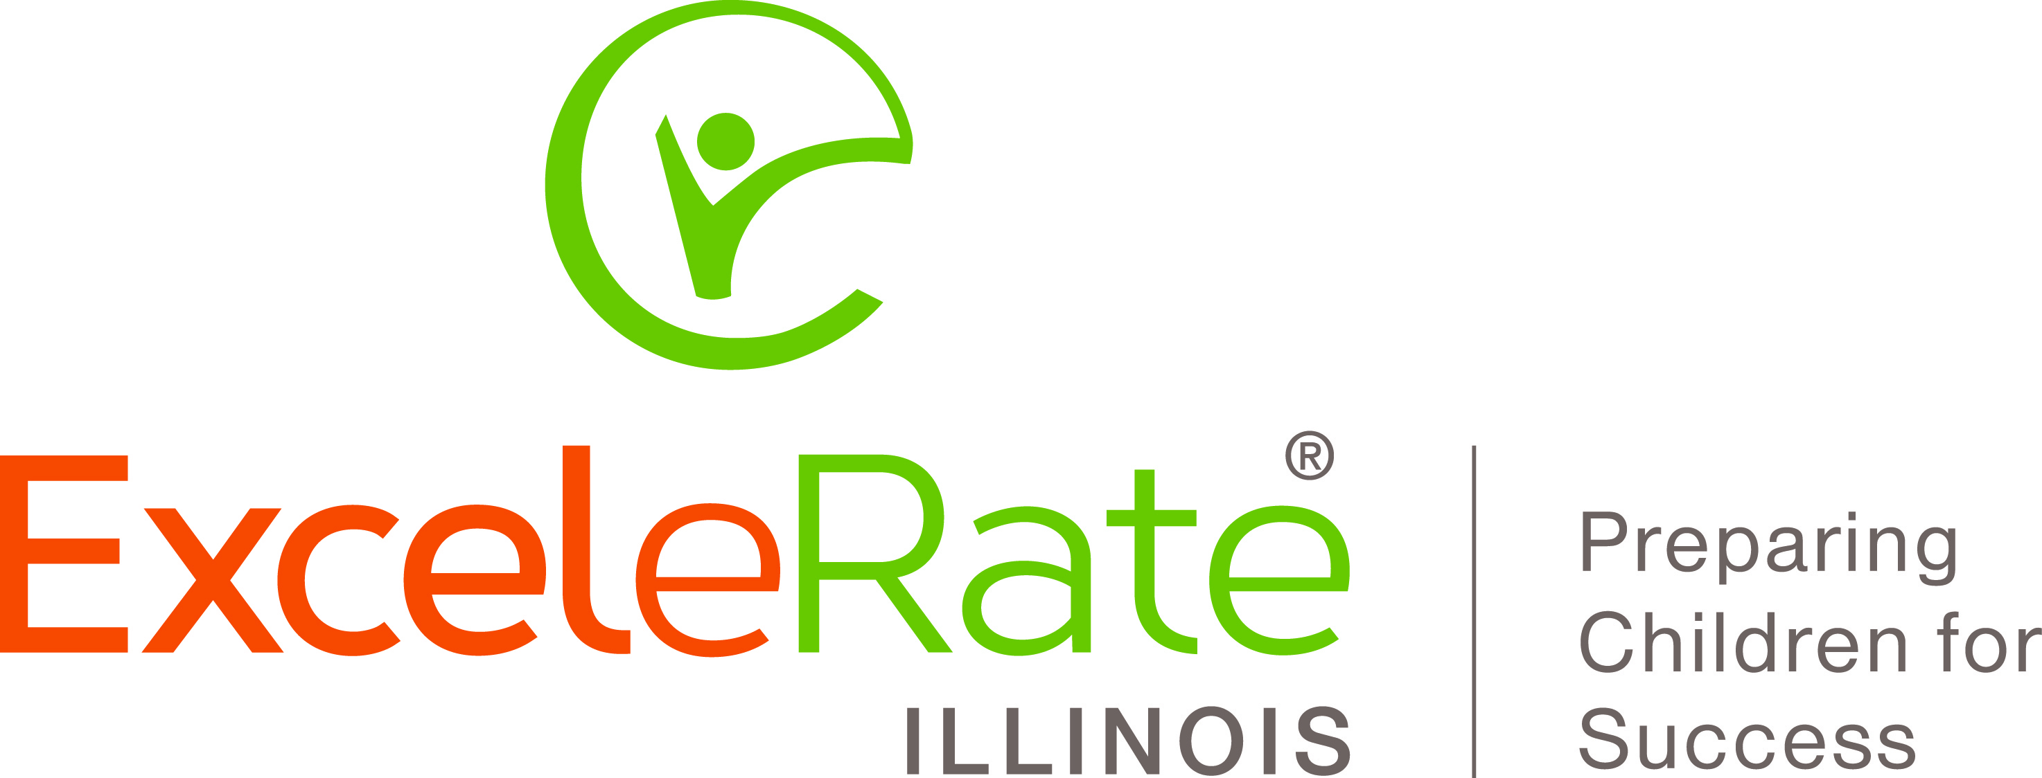
The Illinois Inclusion Guidelines Checklist (IIGC)

This self-study tool is based on the Illinois Inclusion Guidelines, which are at the heart of the Self-Study Portfolio required to obtain the Illinois Award of Excellence in Inclusion of Children with Special Needs. The IIGC provides a framework for collaborative discussion as programs examine program policies and practices that reflect high-quality inclusion. As you consider and gather the types of evidence that your program will use in your Portfolio, consider how well your program meets the intent of each item. The evidence that you consider should be recent (within the past year or from the most recent monitoring and assessment visit related to being a Gold Circle program). All voices are important as you consider each item. You will use these ratings to establish goals and plans for your program.

Items | Not Yet  Developed | Being Developed | Partially Implemented | Fully Established | Notes
1A. Learning Environment
1 - Program and classroom spaces are accessible to all children, and adaptive furniture and equipment for routine care and for indoor and outdoor play and learning, support inclusion of children with special needs in all activities with other children.
2 - Accommodations are made to classroom play and teaching materials to support each child's participation in peer interactions, the general curriculum, and learning opportunities related to their own individual goals and outcomes.
1B. Curriculum
3 - Teachers, other direct service staff, and administrative support staff collaborate with families to identify goals and outcomes from the general education curriculum and from individual education and service plans such as IFSPs and IEPs to incorporate into play, activities, and classroom routines.
1C. Instructional Quality
4 - Strategies, supports, and services identified in individual service plans are provided in the classroom and are embedded into classroom play, activities, and routines.
5 - Classroom and program staff help each child engage in positive, sustained social interactions and play with peers, and provide opportunities for each child to be a fully participating member of the classroom community.
6 - Classroom staff support development and learning by matching individual support strategies such as modeling, asking questions, and prompting to abilities, goals, and intended outcomes of individual children.
1D. Child Screening
7 - Specific markers (e.g., low energy, withdrawal, acting out), targeted screening (e.g., social emotional screening) and ongoing observation and documentation are used in addition to broad-based screening to identify and refer children and families who may benefit from further evaluation or specialized services.
1E. Child Assessment
8 - The program has written procedures and guidelines for gathering information from families on their priorities, goals and desired outcomes for their child's participation in the program, as well as on family routines and strategies that support their child's development and learning.
9 - Classroom and special service staff collaborate in implementing and using initial and ongoing assessment for classroom and special service planning, and in summarizing and reviewing individual and group outcomes for evaluation and modification of classroom effectiveness.
1F. Inclusion of Children with Special Needs
10 - Written policies and procedures encourage and support collaboration and partnership among internal and external personnel and agencies serving the same child and family, including specific guidelines for joint planning, decision-making and problem solving related to educational, behavioral, medical, adaptive, social service, or other individual needs and resources, with family consent.
11 - Program's advisory committee and/or parent board is regularly updated about policy and practices related to inclusion and special needs, and actively recruits parents of children with special needs for service on the committee or board.
2A. Family and Community Engagement
12 - Families of children with special needs are included in all family activities provided or facilitated by the program, and information about the program's vision and strategies for inclusion of all children is shared with all families.
13 - Written policies and procedures encourage and support families of children with special needs as partners in screening, assessment, choosing desired outcomes and setting goals, and instruction related to their child; support frequent communication between families, classroom and other direct service staff; and involve families in evaluating the program in relation to their goals and desired outcomes for their children.
14 - Teachers collaborate with families, other service staff, and administrative support staff to incorporate individual and classroom goals, strategies, and supports into family routines at home and in the community.
15 - Written policies and procedures identify and promote access to internal and external resources that assist families in accessing needed systems, services, and public benefits, including receiving individual support for finding, understanding, negotiating, participating in, and coordinating services among Early Intervention, special education, and other systems (e.g., social services, health, supplemental security income) working with their child both within the program and in the community.

16 - The program administrator and other management staff (e.g., administrative support staff) participate regularly in community and state systems and activities that support public knowledge of and coordination and integration among services for children and families, including those with special needs, and provides leadership for high quality inclusion within the program.
17 - Written agreements support collaboration among members of the local early childhood community (child care, the Early Intervention system, Head Start, public school early childhood program), including written procedures, roles, and responsibilities for shared tasks and activities (e.g., identifying children and families in need of services, sharing information, coordinating services, providing special services to children with special needs and their families, evaluating child and family outcomes).
2B. Transitions
18 - Program policies, procedures, and practices to support transition of children with special needs entering into and exiting from the program are included in partnership agreements and include timelines, roles, and responsibilities of both sending and receiving programs, including responsibilities for sharing and transferring records.
3B. Group Size and Ratios
19 - Early childhood programs and classrooms within which children with special needs are served meet agency, state, and federal requirements for programs and classrooms that include children with special needs and their families.
3C. Continuous Quality Improvement
20 - Program administrators engage staff in systematic, collaborative initial and ongoing program and classroom self-assessment using the Illinois Inclusion Guidelines Checklist, and demonstrate progress toward achieving program goals based on results of the assessment, as stated on an individual program development plan.
21 - Teachers and special service staff engage in systematic initial and ongoing self-assessment using the Inclusive Classroom Profile, and demonstrate progress toward achieving classroom and individual professional development goals based on results of the assessment.

Signatures of Participants in Discussion
(Please provide signatures for all administrators and staff whose work is a part of this award)

I verify that I participated in discussion of these standards in preparation for applying for this award:

Early Childhood Administrator(s):

___________________________________________________________________________________________________________

Classroom Teacher(s):

___________________________________________________________________________________________________________

Special Service Staff:

___________________________________________________________________________________________________________

Coach/Consultant (if appropriate):

___________________________________________________________________________________________________________

I, the primary Administrator responsible for this process, verify that the individuals signing above participated in discussion of these standards in preparation for applying for this award:

___________________________________________________________________________________________________________
EX100©2015 INCCRRA

